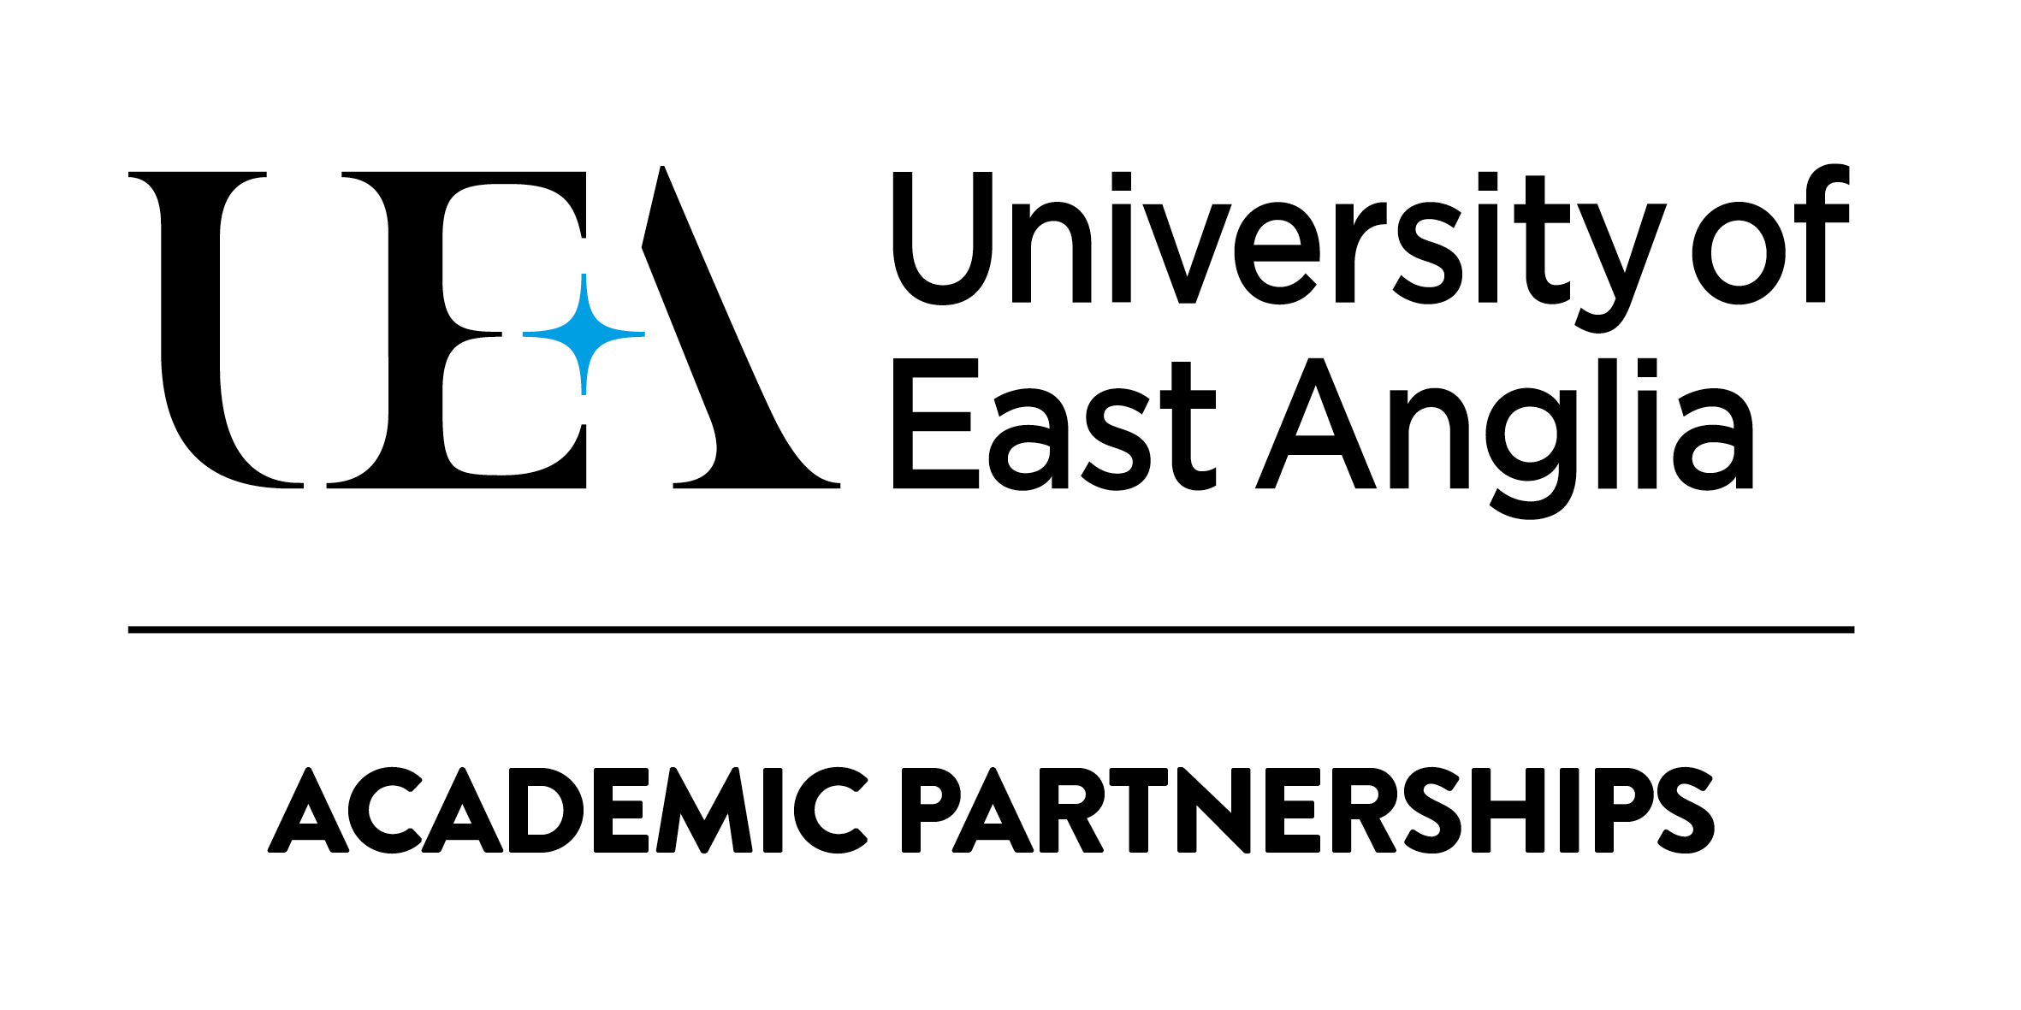Academic Complaint Form
Stage One (Formal Stage)
Partner Institutions

You should complete this form if you want to formally raise concerns about academic matters not relating to academic results. We will take your concerns seriously and our procedure is designed to enable the circumstances to be considered fully and action to remedy the situation, where appropriate.

You can find guidance on the complaints process and help with completing the forms on the UEA Academic Partnerships website at:

https://www.uea.ac.uk/web/about/partnership-hub/academic/work-with-us/resources/partnerships-handbook/appeals-and-complaints
If you choose to submit a Stage One Academic Complaint (Formal Stage), you are strongly advised to seek advice from the student services department at your institution.

It is preferable to submit your complaint form and supporting evidence electronically and in PDF format. A paper copy will be accepted only if circumstances prevent you submitting electronically. The boxes below will expand automatically when you type into them. Please ensure that you attach copies of all evidence with your form.

Please submit this form within 10 working days of the date on which the attempt to resolve matters informally was concluded.

- Your Personal Details
Title
First name
Last name
Name of institution
Name of course
Undergraduate or Postgraduate
Address (the postal address you wish us to use to communicate with you about your appeal)
 | Postcode
Institution email address
Personal email address (if you wish us to also send communication about your appeal to a personal address)
Are you a Tier 4 visa student? | Yes ☐ |  | No ☐

- Your Academic Complaint
What do your concerns relate to? (e.g. library resources, teaching, classrooms, the information you have been given, supervision, research training)
What is your academic complaint? (please explain why you are dissatisfied with the above aspect of your programme of study or its associated facilities)
How would you like your concerns to be addressed?

- Supporting Evidence
Please note: you are responsible for providing all the evidence you wish to be considered with your complaint at the time of submission. You will not be reminded about submitting evidence if you fail to provide it. Complaints that are submitted without supporting evidence will be considered but very rarely succeed.
Evidence must be submitted in English. Where the original evidence is written in a different language an official translation must be submitted along with the original evidence. Translations of evidence will not be considered without sight of the original.
You should provide supporting evidence for the circumstances listed in relation to your complaint. Please list and number the evidence below:
1.
2.
3.
4.
5.
6.
7.
8.
9.
10.

- Checklist
Please use this section to ensure you have completed your complaint correctly
You must:
☐ | Read the Academic Complaints Guidance document:  https://www.uea.ac.uk/web/about/partnership-hub/academic/work-with-us/resources/partnerships-handbook/appeals-and-complaints
☐ | Enter your contact details (section 1)
☐ | Provide details about your concerns (section 2)
☐ | Read, sign and date the declaration (section 5)
☐ | Attach your evidence in PDF format with this form in PDF format

- Declaration
I confirm that the information given on this form and in the supporting documents is true to the best of my knowledge and belief. I confirm that where I have submitted evidence all documents are true copies of the original document, and where evidence relates to a third party, that I have obtained the permission of the said third party to submit the evidence with this complaint. I understand that I should not submit original documents and that submitted documents in support of my academic complaint cannot be returned to me.

If submitting this form via email, please insert your scanned signature or type your name in the signature box below:

Signed
Date

DOCUMENT OWNER: Gavin Tash

DOCUMENT TYPE: Form

APPROVED BY: Academic Partnerships

VERSION NUMBER: 4.0

DUE FOR REVIEW: August 2023

SUMMARY:

Partner institution Stage One Academic Complaint form

VERSION LOG:
Date | Version no. | Summary of changes | Author | Approved by
August 2018 | 1.0 |  | Academic Partnerships | Academic Partnerships
August 2019 | 2.0 | Updated to reflect new website address | Academic Partnerships | Academic Partnerships
September 2020 | 3.0 | Updated to reflect new website address | Academic Partnerships | Academic Partnerships
August 2022 | 4.0 | Updated to reflect new Academic Appeals and Complaints Regulations | Academic Partnerships | Academic Partnerships

